Problem 1

1. cdac@LAPTOP-QVC7TEML:~$ mkdir LinuxAssignment

cdac@LAPTOP-QVC7TEML:~$ cd LinuxAssignment

2. cdac@LAPTOP-QVC7TEML:~/LinuxAssignment$ nano file1.txt

cdac@LAPTOP-QVC7TEML:~/LinuxAssignment$ cat file1.txt

hi

no

yes

thanks

good

bad

yapping

yapper

yapper_mod

3. cdac@LAPTOP-QVC7TEML:~/LinuxAssignment$ mkdir docs

4.cdac@LAPTOP-QVC7TEML:~/LinuxAssignment$ cp file1.txt docs/file2.txt

cdac@LAPTOP-QVC7TEML:~/LinuxAssignment$ mv docs file2.txt

cdac@LAPTOP-QVC7TEML:~/LinuxAssignment$ ls

file1.txt file2.txt

5. cdac@LAPTOP-QVC7TEML:~/LinuxAssignment$ sudo chmod a+wx file1.txt

[sudo] password for cdac:

cdac@LAPTOP-QVC7TEML:~/LinuxAssignment$ ls -l file2.txt

total 4

-rw-r--r-- 1 cdac cdac 53 Aug 28 18:04 file2.txt

6. cdac@LAPTOP-QVC7TEML:~/LinuxAssignment$ ls

docs file1.txt

7. ------cdac@LAPTOP-QVC7TEML:~/LinuxAssignment$ find . -type f -name "*.txt"

./docs/file2.txt

./file1.txt

---- cdac@LAPTOP-QVC7TEML:~/LinuxAssignment$ grep 'yapper' file1.txt

yapper

yapper_mod

8.cdac@LAPTOP-QVC7TEML:~/LinuxAssignment$ date

Wed Aug 28 18:19:26 IST 2024

9. ---------cdac@LAPTOP-QVC7TEML:~/LinuxAssignment$ hostname -I

172.20.62.103

----cdac@LAPTOP-QVC7TEML:~/LinuxAssignment$ ping -c 4 google.com

PING google.com (172.217.27.174) 56(84) bytes of data.

64 bytes from kix05s07-in-f174.1e100.net (172.217.27.174): icmp_seq=1 ttl=110 time=18.1 ms

64 bytes from del11s03-in-f14.1e100.net (172.217.27.174): icmp_seq=2 ttl=110 time=15.0 ms

64 bytes from del11s03-in-f14.1e100.net (172.217.27.174): icmp_seq=3 ttl=110 time=14.0 ms

64 bytes from del11s03-in-f14.1e100.net (172.217.27.174): icmp_seq=4 ttl=110 time=13.5 ms

--- google.com ping statistics ---

4 packets transmitted, 4 received, 0% packet loss, time 3005ms

rtt min/avg/max/mdev = 13.520/15.168/18.146/1.796 ms

10. cdac@LAPTOP-QVC7TEML:~/LinuxAssignment$ zip -r docs.zip file1.txt

adding: file1.txt (deflated 21%)

cdac@LAPTOP-QVC7TEML:~/LinuxAssignment$ unzip docs.zip -d extracted_docs

Archive: docs.zip

inflating: extracted_docs/file1.txt

cdac@LAPTOP-QVC7TEML:~/LinuxAssignment$ cd extracted_docs

cdac@LAPTOP-QVC7TEML:~/LinuxAssignment/extracted_docs$ cd ..

cdac@LAPTOP-QVC7TEML:~/LinuxAssignment$ cat extracted_docs

cat: extracted_docs: Is a directory

cdac@LAPTOP-QVC7TEML:~/LinuxAssignment$ cd extracted_directory

-bash: cd: extracted_directory: No such file or directory

cdac@LAPTOP-QVC7TEML:~/LinuxAssignment$ cd extracted_docs

cdac@LAPTOP-QVC7TEML:~/LinuxAssignment/extracted_docs$ ls

file1.txt

11. cdac@LAPTOP-QVC7TEML:~/LinuxAssignment$ echo "YAPPERISTA" >> file1.txt

cdac@LAPTOP-QVC7TEML:~/LinuxAssignment$ sed -i 's/yapper_mod/yappper_god/g' file1.txt

cdac@LAPTOP-QVC7TEML:~/LinuxAssignment$ cat file1.txt

hi

no

yes

thanks

good

bad

yapping

yapper

yappper_god

YAPPERISTA

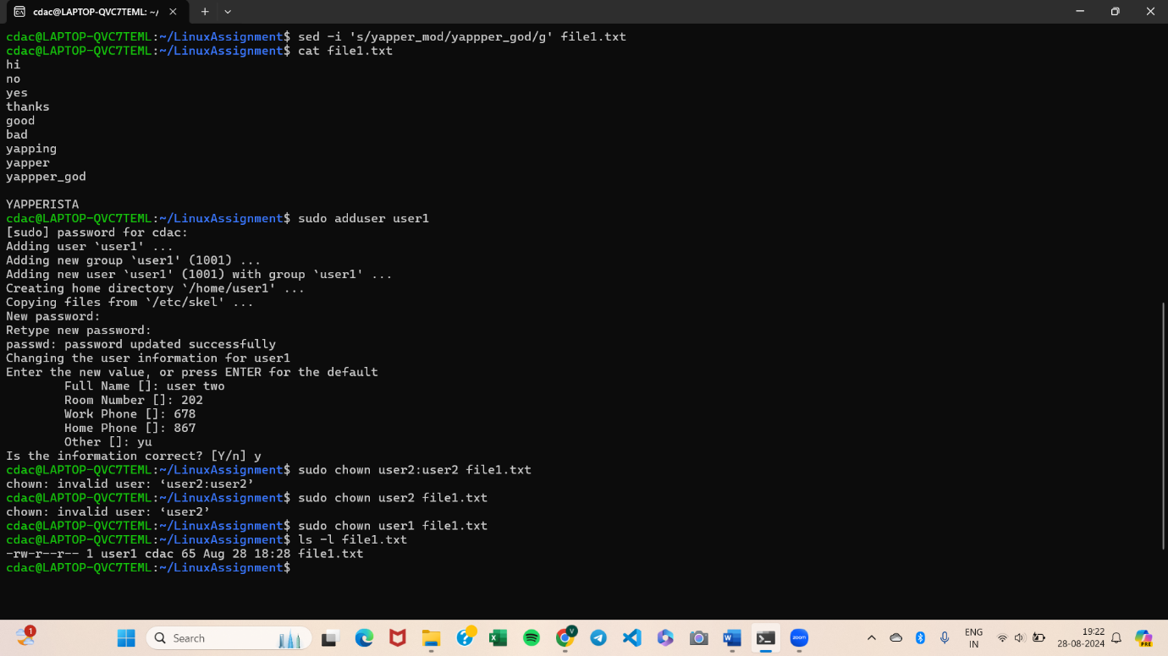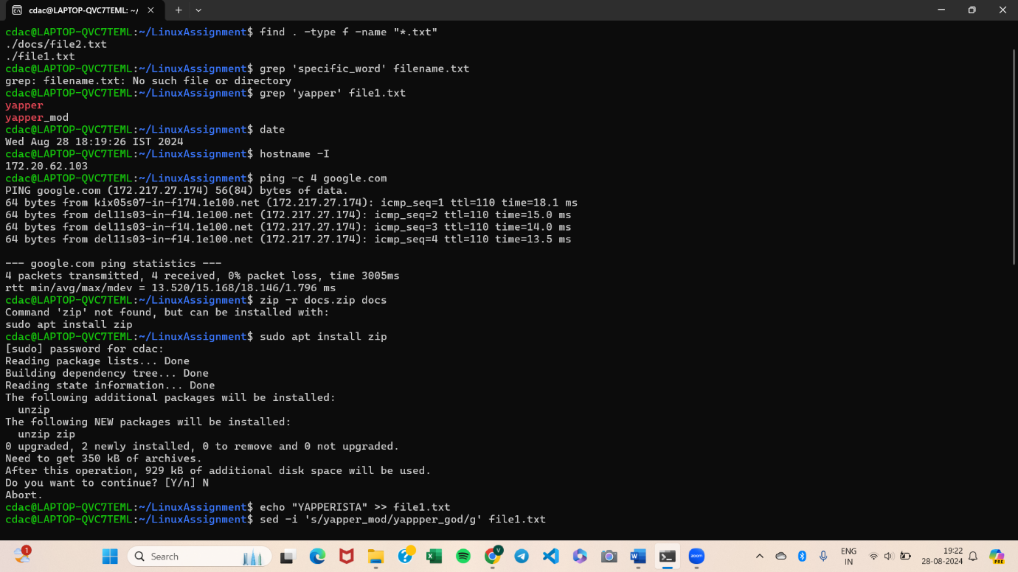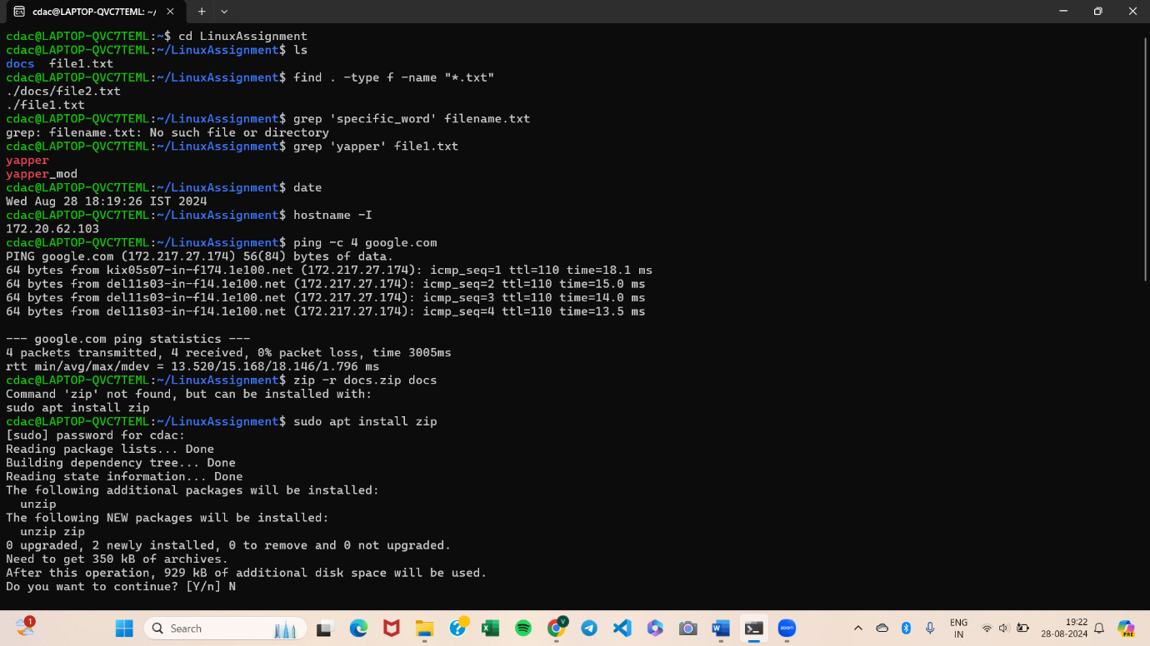

Problem 2:

1. cdac@LAPTOP-QVC7TEML:~/LinuxAssignment$ head -10 file1.txt

hi

no

yes

thanks

good

bad

yapping

yapper

yappper_god

2. cdac@LAPTOP-QVC7TEML:~/LinuxAssignment$ head -5 file1.txt

hi

no

yes

thanks

good

3. cdac@LAPTOP-QVC7TEML:~/LinuxAssignment$ nano number.txt

cdac@LAPTOP-QVC7TEML:~/LinuxAssignment$ head -15 number.txt

1

2

3

4

5

6

7

8

9

10

11

12

13

14

15

4. cdac@LAPTOP-QVC7TEML:~/LinuxAssignment$ tail -3 number.txt

15

16

18

5. cdac@LAPTOP-QVC7TEML:~/LinuxAssignment$ tr '[:lower:]' '[:upper:]' < file1.txt > file4.txt

cdac@LAPTOP-QVC7TEML:~/LinuxAssignment$ cat file4.txt

HI

NO

YES

THANKS

GOOD

BAD

YAPPING

YAPPER

YAPPPER_GOD

YAPPERISTA

YAPPINSTER

CUTTER

CUTTING

JUSTI

6. cdac@LAPTOP-QVC7TEML:~/LinuxAssignment$ sort duplicate.txt | uniq

bin

dw

hi

no

num

trt

yes

7. cdac@LAPTOP-QVC7TEML:~/LinuxAssignment$ uniq -c duplicate.txt

1 yes

1 no

1 yes

1 no

2 hi

1 num

1 bin

1 trt

1 dw

